Pso and chimp

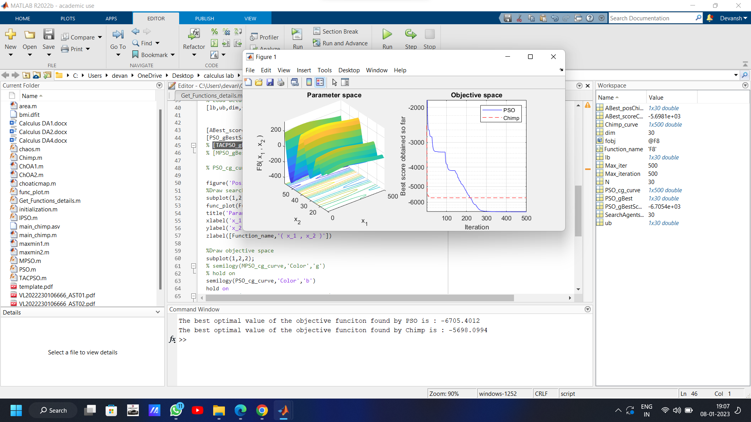



MPSO and CHIMP





ALL





CHIMP and TACPSO

